# **Ultimez Technology**

## **Digital Marketing Task**

1. **SEO Analysis & Optimization plan**

SEO AUDIT for <https://wpwebinfotech.com/>  
  
**Website Overview:**  
WPWeb Infotech offers IT services like WordPress development, web app development, eCommerce solutions, and digital marketing. It's a competitive niche and SEO is key for ranking and traffic.

**3 major issues identified:**

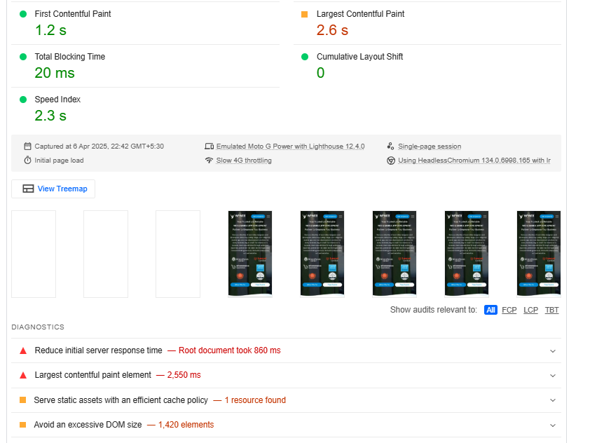  
  
**1. Technical issues:**

**A. Delayed Server Response Time**

* **Issue:**  
  The server took approximately **860 milliseconds** to deliver the initial HTML document, which causes a noticeable delay before the page even begins to load for the user.
* **Tool Used:**  
  Google PageSpeed Insights
* **Solution:**  
  To resolve this, the website should be hosted on a faster and more optimized server. Switching to a performance-focused provider like **LiteSpeed** or **Cloudways** can significantly improve response times.  
  Additionally, enabling full-page caching with tools like **WP Rocket** or **LiteSpeed Cache** helps deliver pages instantly to users. Reducing unnecessary plugins and optimizing backend processes also reduces server load.

**B. Slow Loading of Largest Contentful Paint (LCP)**

* **Issue:**  
  The Largest Contentful Paint, which typically includes banner images or large blocks of text, is taking **2.55 seconds** to fully render. This affects how fast the main content becomes visible to users.
* **Tool Used:**  
  Google PageSpeed Insights
* **Solution:**  
  To improve LCP, large images should be compressed and converted to modern formats like **WebP**.  
  Implementing **lazy loading** for non-visible elements ensures that only essential content is loaded first.  
  Using a **Content Delivery Network (CDN)** such as **Cloudflare** speeds up the delivery of assets.  
  Also, preloading critical assets like hero images or key fonts ensures they are given priority during page load.

**C. Static Files Not Properly Cached**

* **Issue:**  
  Some static files such as CSS, JS, or image files lack long-term caching, causing the browser to download them every time the user visits, which adds to the load time.
* **Tool Used:**  
  Google PageSpeed Insights
* **Solution:**  
  Setting proper cache expiration headers through the .htaccess file ensures that browsers store static files for longer periods.  
  Plugins like **WP Rocket**, **LiteSpeed Cache**, or using **Cloudflare** can automatically apply the correct caching rules.  
  This reduces repeated data transfers and speeds up subsequent visits.

**D. Overloaded DOM Structure**

* **Issue:**  
  The page currently has over **1,420 DOM elements**, which indicates a heavy and complex structure. This can slow down rendering and responsiveness, especially on mobile devices.
* **Tool Used:**  
  Google PageSpeed Insights
* **Solution:**  
  Simplifying the page layout by removing unnecessary sections, widgets, or repeated blocks helps reduce DOM size.  
  Avoid deeply nested elements and try to use cleaner HTML where possible.  
  Page builders like Elementor often generate extra code, so reviewing and minimizing unused elements can improve performance significantly.

**2.** **Lengthy Page Titles (On-Page SEO)**

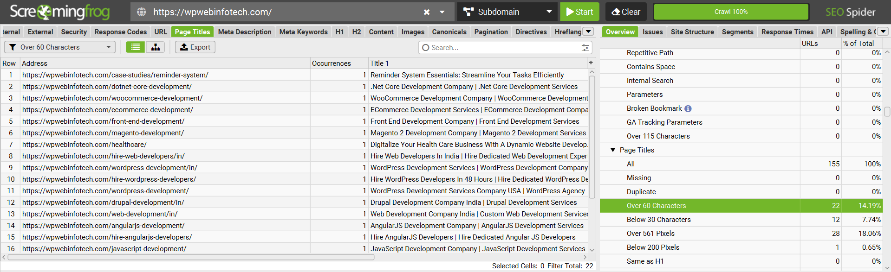

* **Issue:**

22 URLs have title tags over 60 characters.

Example:

WooCommerce Development Company | WooCommerce Development Services

Hire Skilled WordPress Developers in 48 Hours – No Delays, Just Results

* **Impact:**

Titles get truncated in Google SERP, cutting off important messaging.

Keyword-stuffing or repetitive patterns might trigger lower CTR or even algorithmic devaluation.

* **Tool Used**:

Screaming Frog SEO Spider

* **Solution:**

Keep titles within 50–60 characters max.

Focus on user intent + main keyword.

Add unique selling points (e.g., “Affordable WooCommerce Experts” instead of just repeating keywords)**.**

**3. Low-Quality Backlinks (Off-Page SEO)**

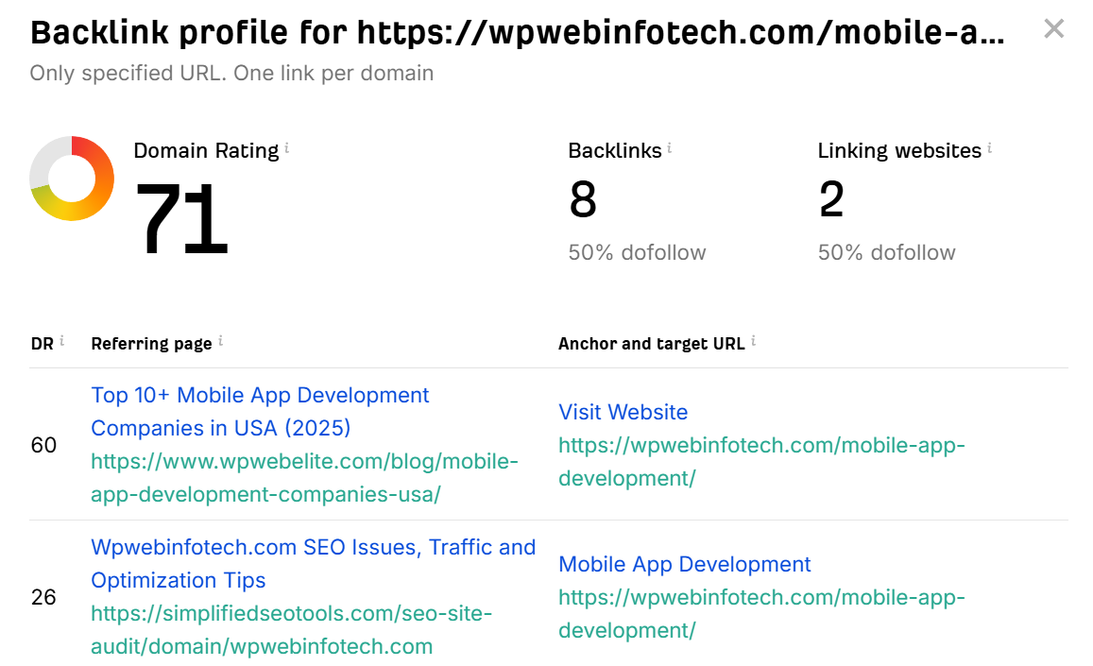

* **Issue:**  
  Some important service pages — such as those offering **Mobile App Development** have less backlinks from external websites. This weak backlink profile makes it harder for these pages to build authority and rank competitively on Google.
* **Impact:**  
  Even with strong on-page SEO, pages without solid backlinks may struggle to appear in top search results. Backlinks serve as trust signals, and without them, search engines may undervalue the page’s relevance.
* **Tools Used:**  
  **Ahrefs Free Backlink Checker**
* **Solution:**  
  To build a stronger backlink profile for these pages:
  1. **Write Guest Posts on Tech Blogs:**  
     Reach out to websites like **Hackernoon**, **TechBullion**, or other tech blogs. Offer to write helpful articles for them, and include a link back to your service pages inside the content. This helps get quality backlinks and builds trust with Google.
  2. **Create Content That Others Want to Share:**  
     Make useful and interesting content like **industry stats, success stories, or online tools**. These types of content naturally get shared and linked by other websites and blogs, which improves your site’s authority and SEO

1. **Content Writing & Optimization:**

**Blog Title:** AI-Powered SEO: The Smartest Way to Rank in 2025

**Meta Title: (55 characters)**

AI SEO Tools 2025 Unleashed Boost Google Rankings Fast

**Meta Description: (156 characters)**

Explore how AI SEO tools in 2025 boost Google rankings, automate keyword optimization, and improve content performance. Get started with AI SEO now!

**Blog Content: (159 words)**

AI is revolutionizing digital marketing in 2025, especially SEO. Tools like SurferSEO, Jasper, KoalaWriter, and Semrush AI now let marketer’s complete complex SEO tasks faster and more efficiently.

From automated keyword research to fully optimized content, AI simplifies every step. These tools improve on-page SEO, refine meta tags, and boost search engine visibility — all with a few clicks.

Beyond saving time, AI helps you create content that aligns with Google’s latest algorithm updates. Whether it's blogs, service pages, or product descriptions, AI ensures content is optimized for both users and search engines.

With SEO automation, brands can now scale content strategies without sacrificing quality. Startups, agencies, and enterprises alike are embracing AI-powered SEO to stay ahead and grow their organic reach.  
  
**CTA button:**  
Boost your traffic with AI tools – Get started today!  
  
**High Performance Keyword: (From SEMRUSH)**

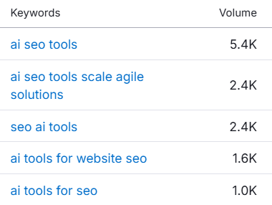

1. **SEO Strategy Execution**

**Service Page for Ultimez:** End-to-End Website Development Services  
  
**5 On-Page SEO Elements to Optimize:**

1. **Title Tag** End-to-End Website Development Services | Ultimez Technology  
    (Includes target keyword + brand name + clear service intent.)
2. **Meta Description**Build high-performing, fully customized websites with Ultimez Technology. End-to-end web development solutions designed to scale your business.(Engaging, under 160 characters, with strong intent.)
3. **Header Tags (H1 to H3)**
   * H1: End-to-End Website Development Services
   * H2: Full-Cycle Development Process
   * H2: Why Choose Ultimez?
   * H2: Technologies We Use
   * H3: Front-End & Back-End Tech Stack
   * H3: Client-Centric Customization

(Clear keyword use with proper semantic structure)

1. **URL Slug:**/services/end-to-end-website-development  
    (SEO-friendly, consistent with site architecture.)
2. **Internal Linking :** Strategically link to related high-value service pages and blogs:
   * UI/UX Design Services
   * Custom Web Application Development
   * SEO Services
   * Our Portfolio
   * Blog: “Why End-to-End Development Saves Costs”

**Two high-authority websites**

**1. Search Engine Journal**

* <https://www.searchenginejournal.com>
* Domain Authority: **91**

**2. Smashing Magazine**

* <https://www.smashingmagazine.com>
* Domain Authority: **88**